
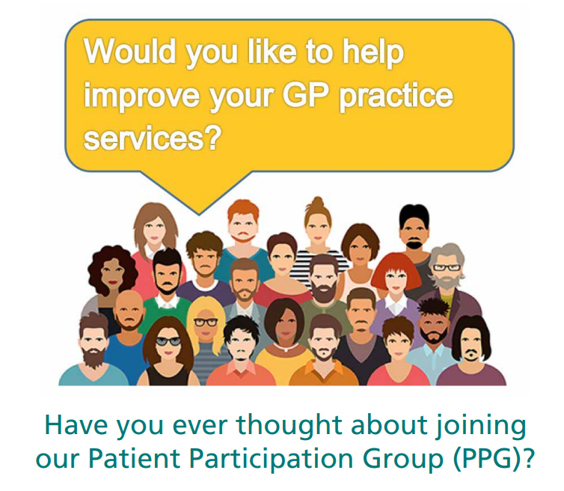
A PPG is a group made up of volunteer patients and members of practice staff who work together to improve the experience of patients using the practice

To find out more we will be at Chinley Community Centre on
Wednesday 18th February
1 pm – 2.30 pm

Or contact the surgery on 01298 812725
or email Samantha on
Samantha.Todd2@nhs.net

